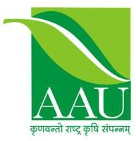 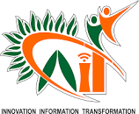

REPORT ON EDUCATIONAL TOUR 2024

(From 08/12/2024 to 23/12/2024)

|  |  |
| --- | --- |
| **Submitted By** | **Tour Coordinator** |
| Name: Roshni Gamit |  |
| Reg. No: 3060820006  Semester: 7th  Roll no: 26 | Dr. Xitij Shukla  (Assistant professor) |
|  |  |

## College of Agricultural Information Technology Anand Agricultural University

**Anand – 388 110**

# Introduction

The educational tour for VII Semester B. Tech. (AIT) students from the College of Agricultural Information Technology, Anand Agricultural University, was conducted from December 8, 2024, to December 24, 2024. The tour covered prominent agricultural, research, and educational institutions across northern India, focusing on gaining practical insights into various agricultural advancements and technologies. The total distance covered during the tour was approximately 4000 kilometers.

# INDEX

|  |  |  |  |
| --- | --- | --- | --- |
| **Date** | **Institute Name** | **Place** | **Page No.** |
| 9/12/2024 | Sri Karan Narendra Agriculture University (Horticultural Department), Jobner | Jobner | 1 |
| 29/12/2024 | National Bureau of Plant Genetic Resources (NBPGR), Delhi | Delhi | 2 |
| 1/12/2024 | ICAR-National Dairy Research Institute (NDRI), Karnal | Karnal | 3 |
| 1/12/2024 | ICAR-Sugarcane Breeding Institute, Karnal | Karnal | 6 |
| 4/12/2024 | Krishi Vigyan Kendra (KVK), Kullu | Kullu | 7 |
| 4/12/2024 | Central Potato Research Institute (CPRI), Shimla | Shimla | 9 |
| 6/12/2023 | Indian Institute of Remote Sensing (IIRS), Dehradun | Dehradun | 10 |

## Visit : Sri Karan Narendra Agriculture University (Horticultural Department and Soil Science Department), Jobner

### Date : 28/11/2023

Our tour began with a visit to the Sri Karan Narendra Agriculture University in Jobner, Jaipur. Renowned for its pioneering work in dryland farming, the university provided a glimpse into innovative techniques aimed at sustainable agriculture in arid regions.

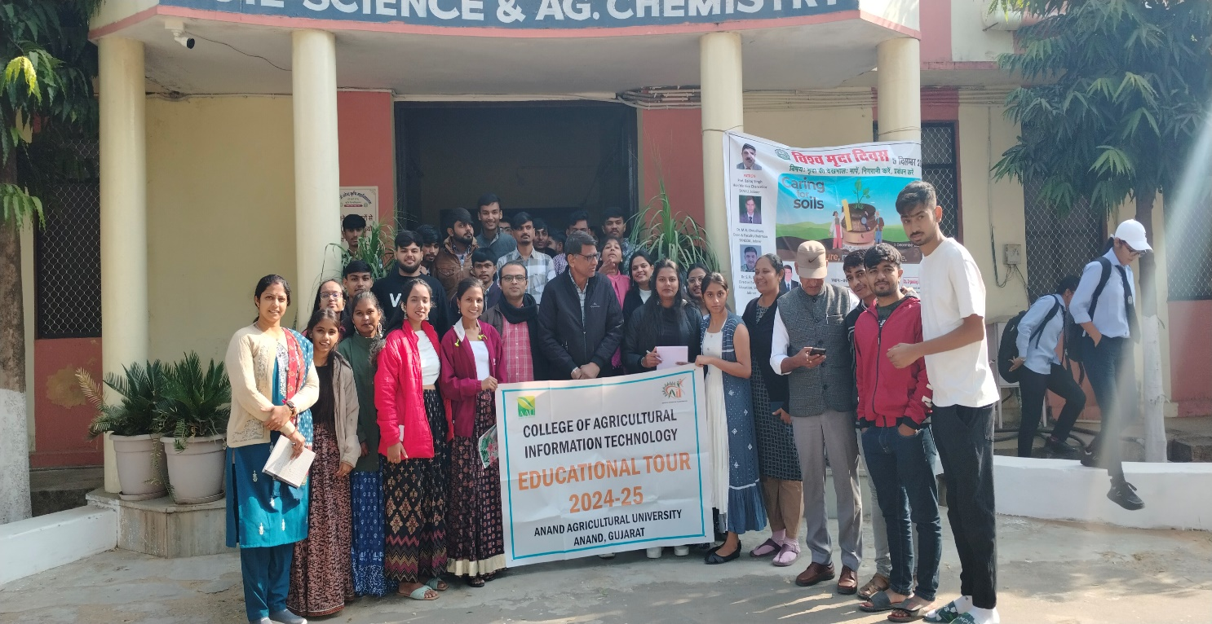

During our visit, we explored the **Department of Agronomy**, which focuses on optimizing crop management practices, particularly in arid and semi-arid regions. Faculty members demonstrated research on crop management, including the development of drought-resistant crop varieties and innovative irrigation techniques such as drip and sprinkler systems. We learned about the implementation of integrated nutrient management strategies, balancing organic and inorganic resources to enhance soil fertility. The department’s experimental fields show cased real-world applications of these techniques, offering valuable insights into sustainable agriculture tailored for water-scarce regions.

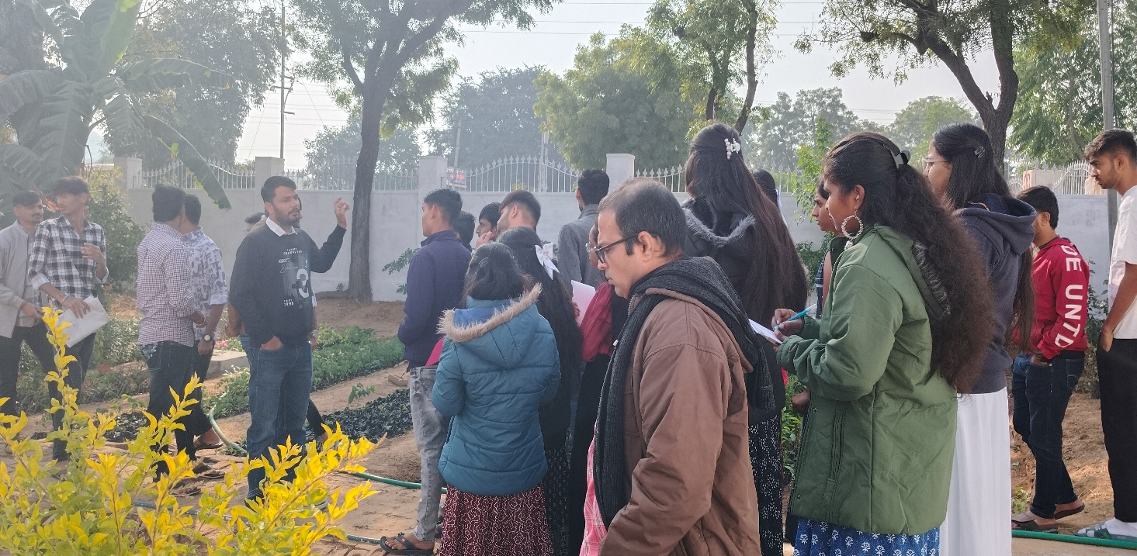

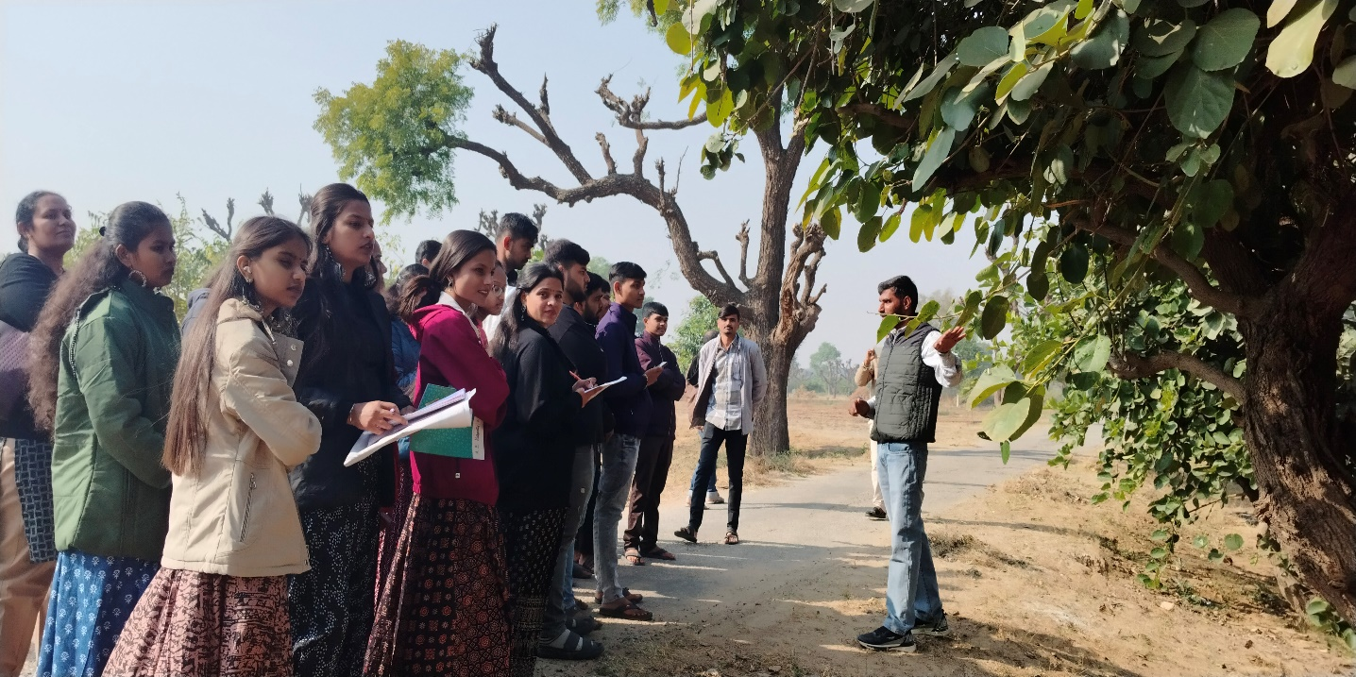

## Visit : National Bureau of Plant Genetic Resources (NBPGR), Delhi

### Date : 29/11/2023

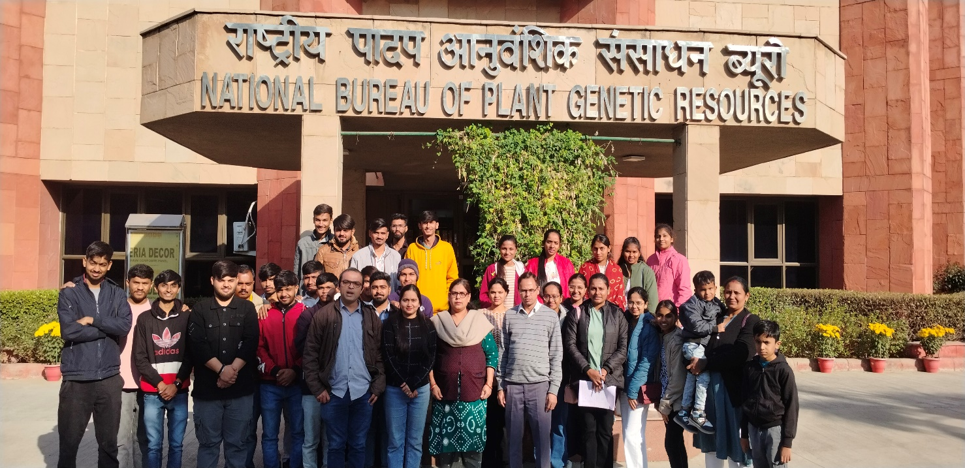

Next, we visited the ICAR-National Bureau of Plant Genetic Resources in New Delhi. This institute plays a pivotal role in the conservation and management of plant genetic resources. We explored their gene bank, housing a vast collection of seeds and plant specimens crucial for biodiversity preservation. The hands-on activities enriched our understanding of germplasm conservation techniques.

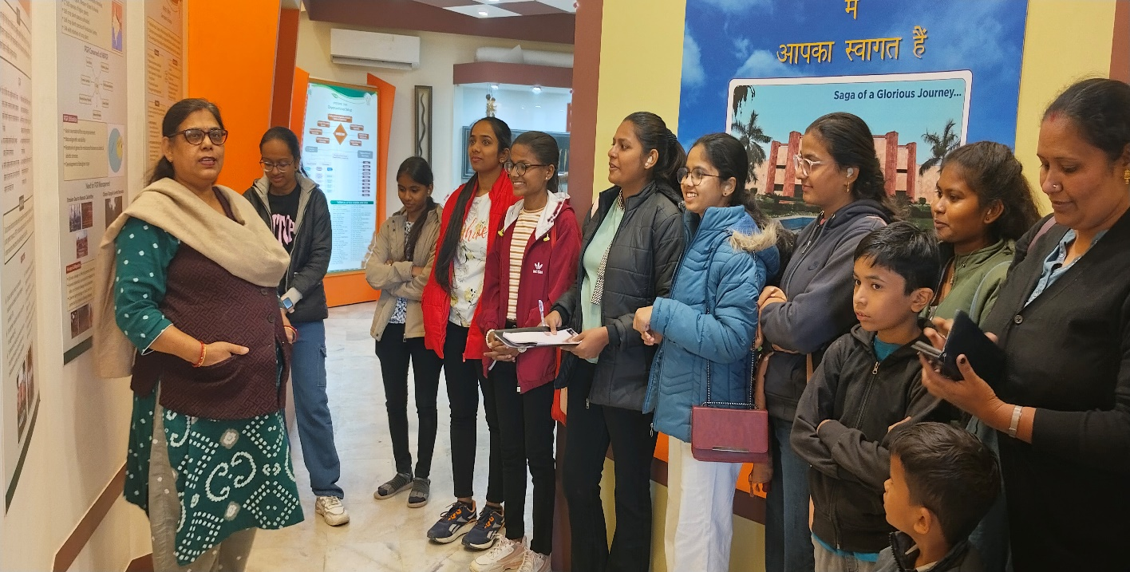

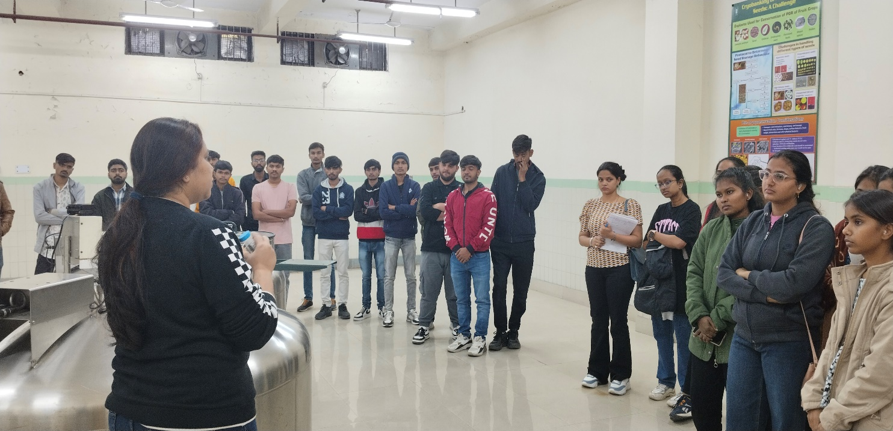

**Visit : ICAR-National Dairy Research Institute (NDRI), Karnal**

### Date : 01/12/2023

### 

At the National Dairy Research Institute in Karnal, we delved into advancements in dairy science and technology. The institute's state-of-the-art labs and dairy processing units showcased innovations in milk production and quality control. We also learned about the role of biotechnology in enhancing dairy cattle productivity.

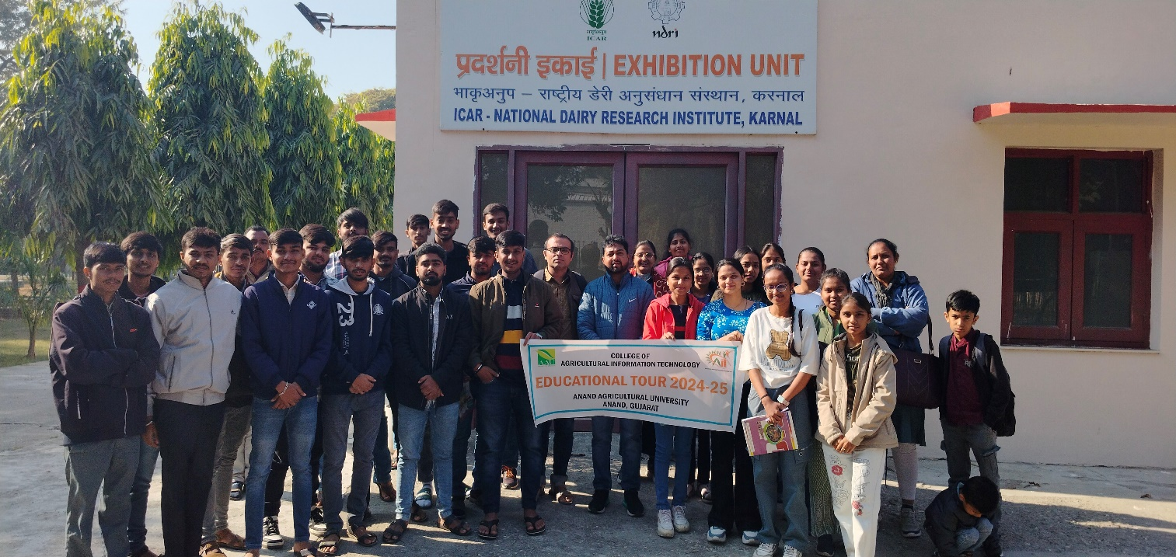

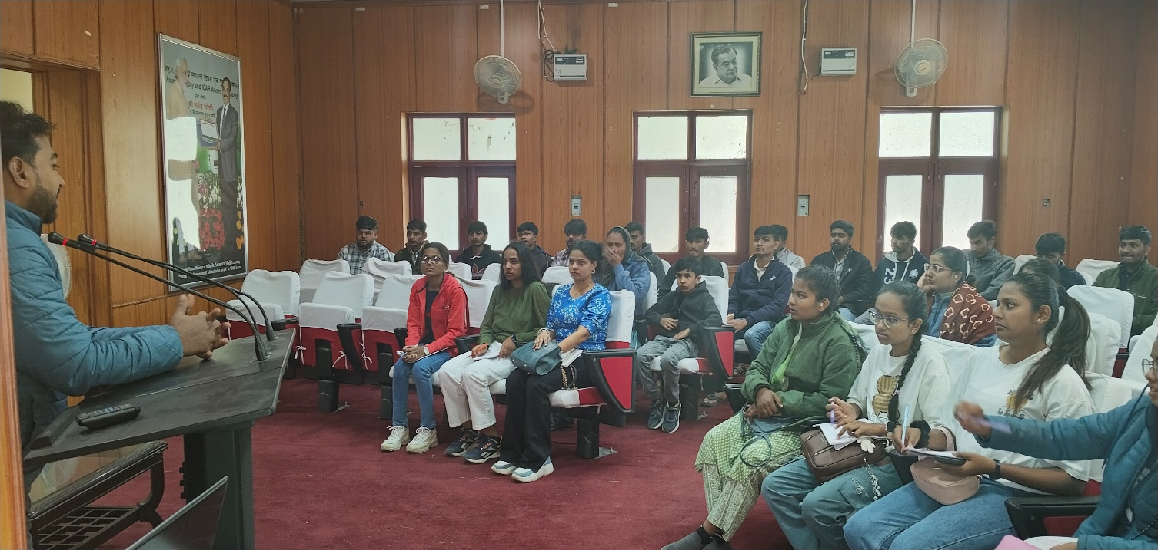

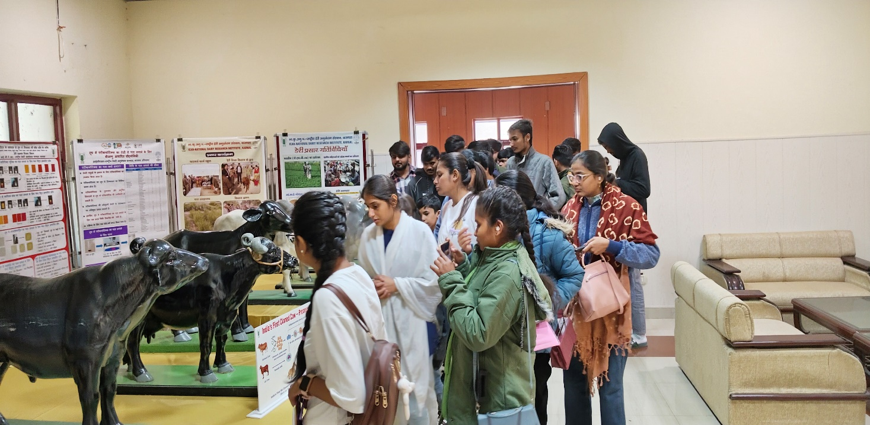

* Dairy Production Research
* Dairy Processing Technologies
* Biotechnology in Dairying
* Practical Demonstrations
* Animal Health Programs

The visit underscored the critical role of integrated dairy farming practices in ensuring high-quality milk production while maintaining animal welfare. The faculty and researchers provided valuable insights into the challenges and opportunities in the dairy sector, inspiring us to consider innovative solutions for the future.

## Visit: ICAR-Sugarcane Breeding Institute, Karnal

### Date : 1/12/2023

In Karnal, Haryana, the ICAR-Sugarcane Breeding Institute provided insights into sugarcane cultivation and varietal improvement. The institute is dedicated to enhancing sugarcane production through advanced breeding techniques, pest management strategies, and sustainable cultivation practices. During the visit, we interacted with the researchers who explained the development of high-yield and disease-resistant sugarcane varieties tailored for different agro-climaticregions.

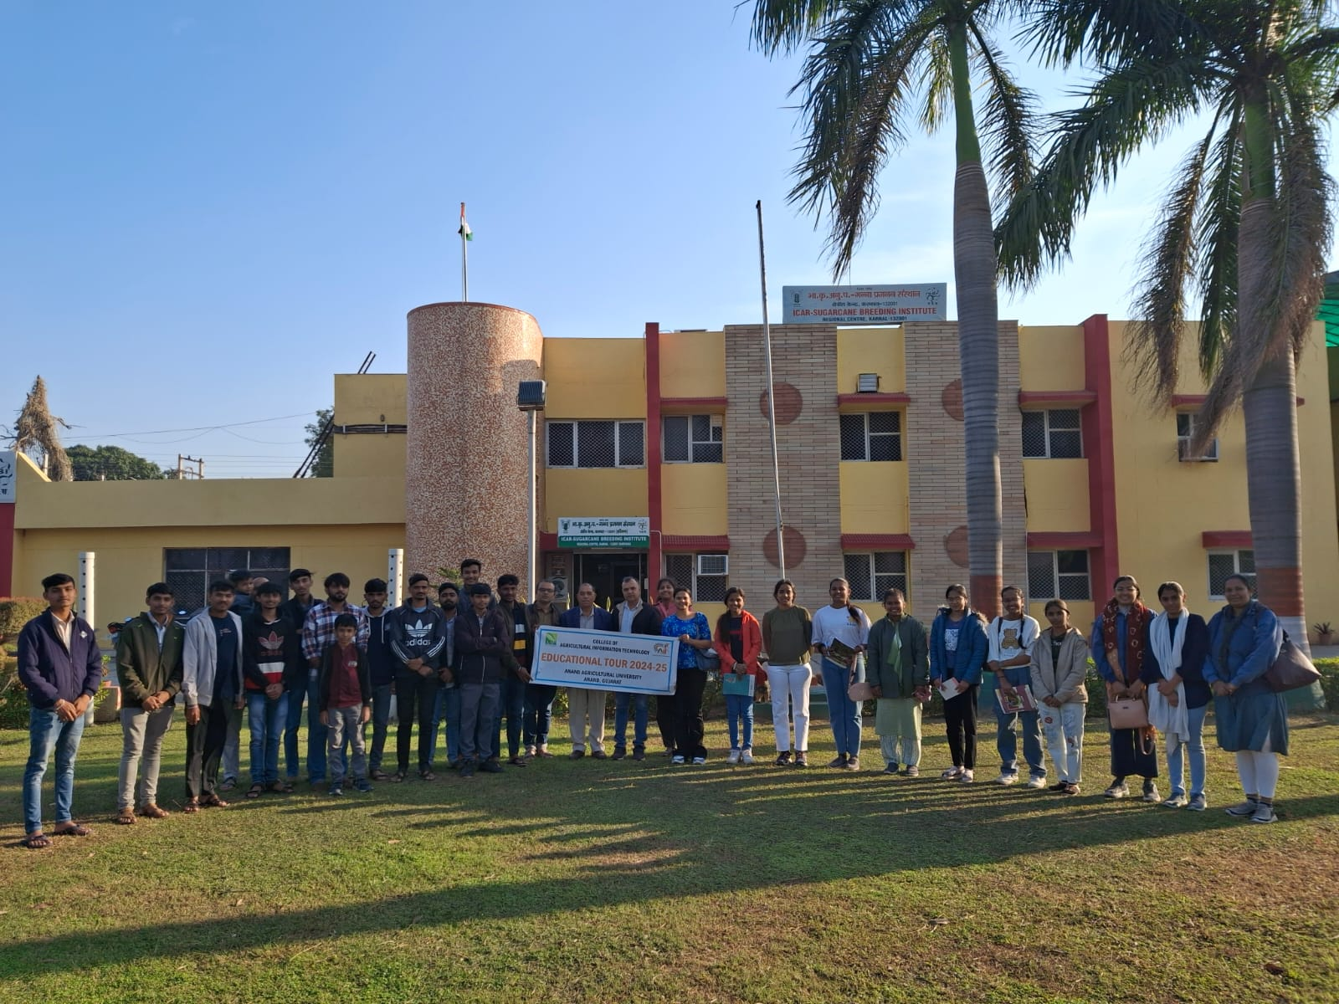

A unique highlight of our visit was the staff’s preparation of fresh sugarcane juice, allowing us to experience firsthand the sweetness and freshness of the crop. This interactive activity emphasized the importance of quality control from farm to final product.

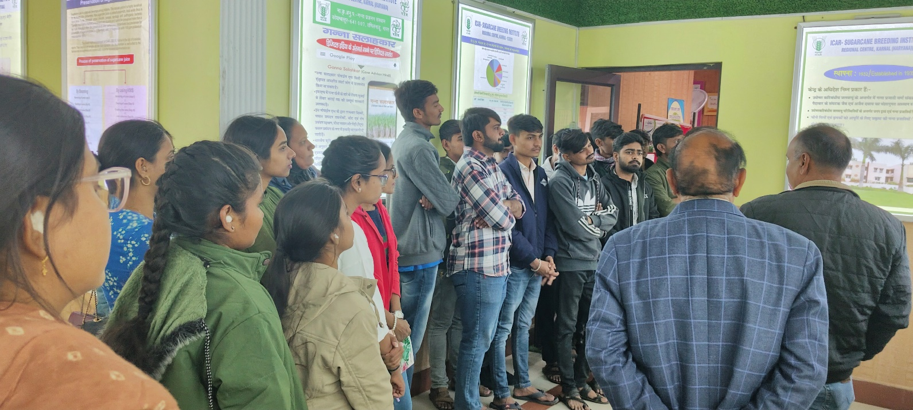

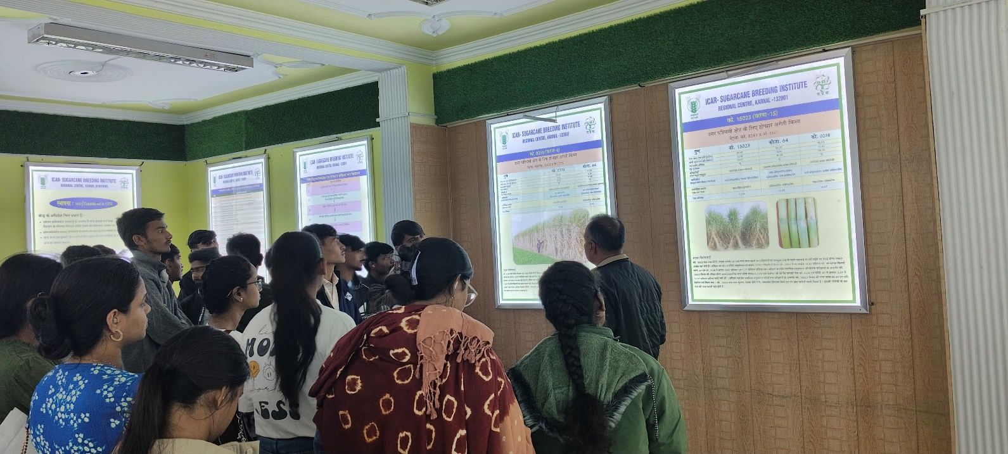

## Visit : Krishi Vigyan Kendra (KVK), Kullu

### Date : 4/12/2023

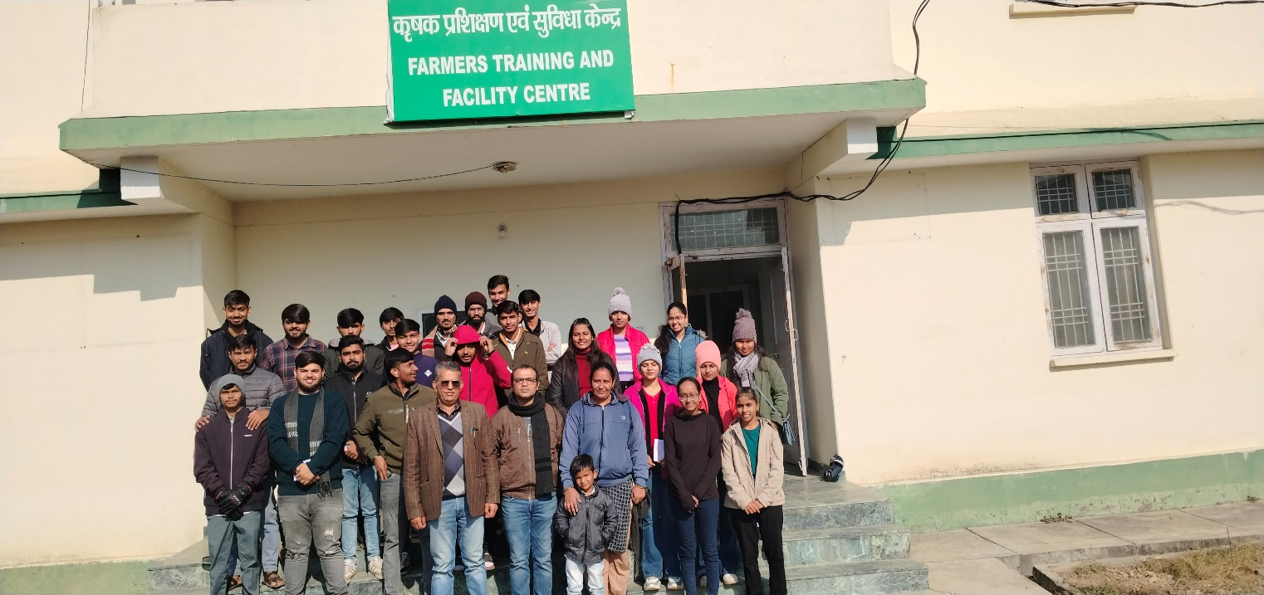

The Krishi Vigyan Kendra (KVK) in Kullu is dedicated to the dissemination of agricultural knowledge and technologies among farmers in hilly regions.

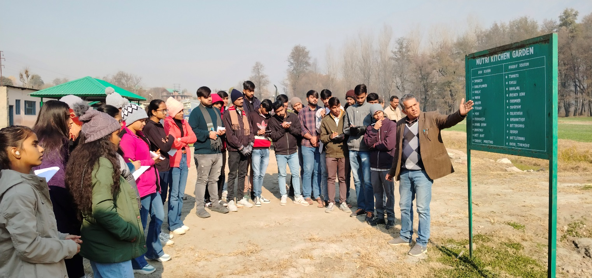

* **Demonstration Plots:** We observed experimental plots demonstrating high-value crops like apples, plums, and other temperate fruits, along with floriculture practices.
* **Training Programs:** The KVK offers capacity-building programs for local farmers, focusing on organic farming, integrated pest management (IPM), and vermicomposting.
* **Horticultural Practices:** The experts show cased sustainable practices for horticulture in mountainous terrains, emphasizing soil conservation and irrigation management.
* **Bee-Keeping and Apiary Management:** A demonstration on bee-keeping practices highlighted the importance of pollination in improving crop yields.

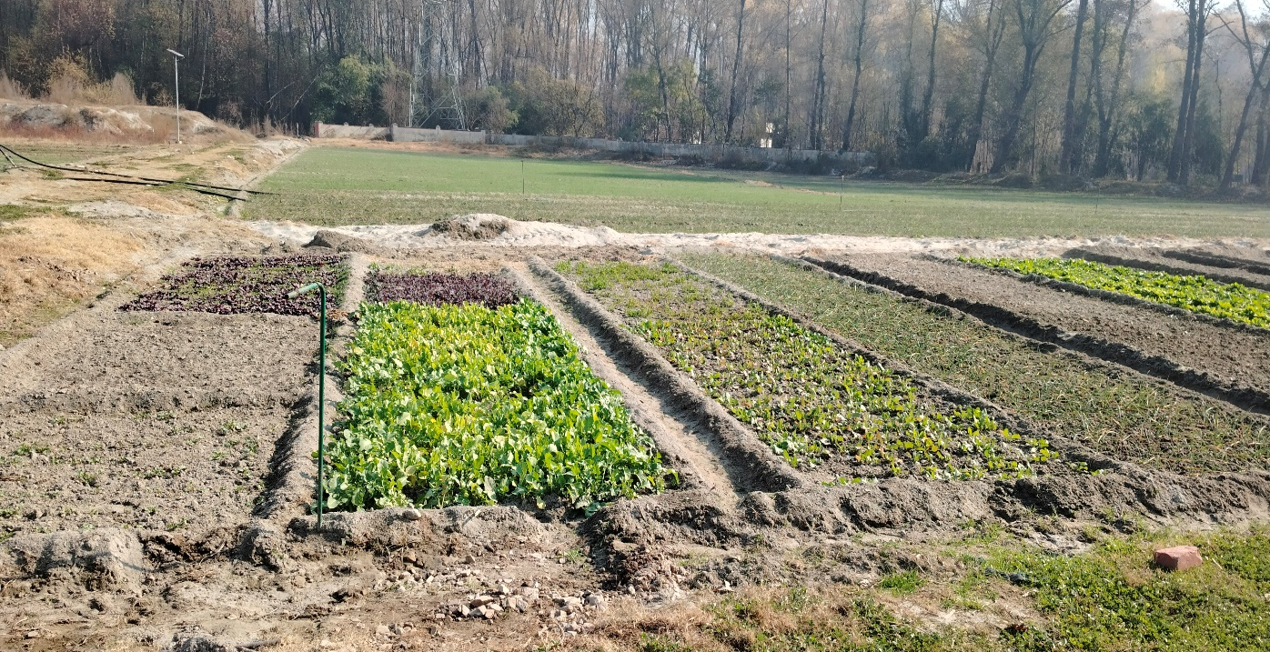

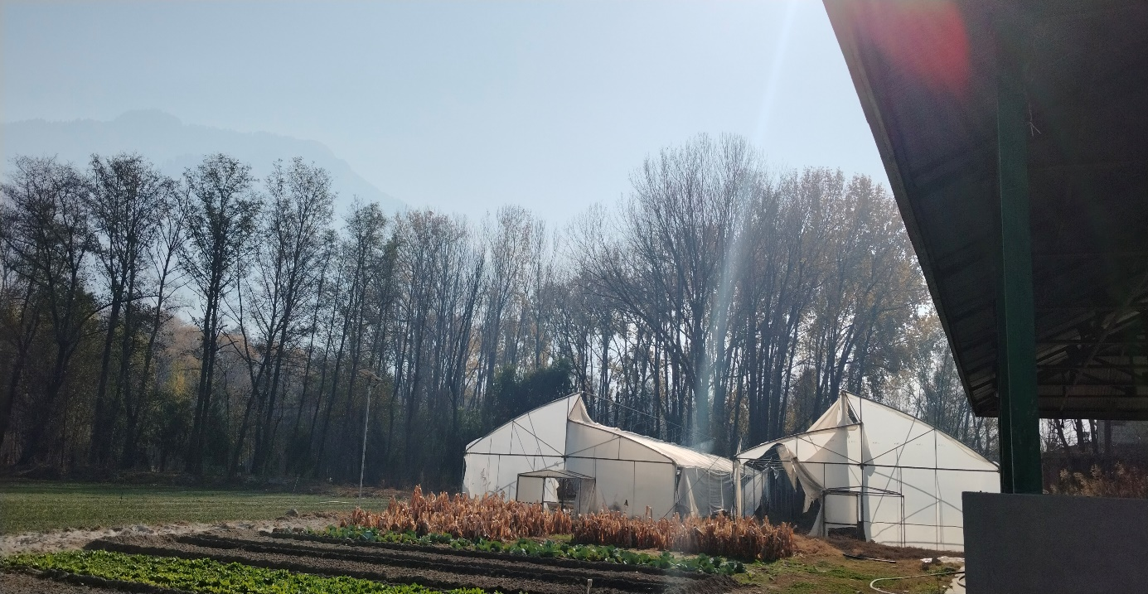

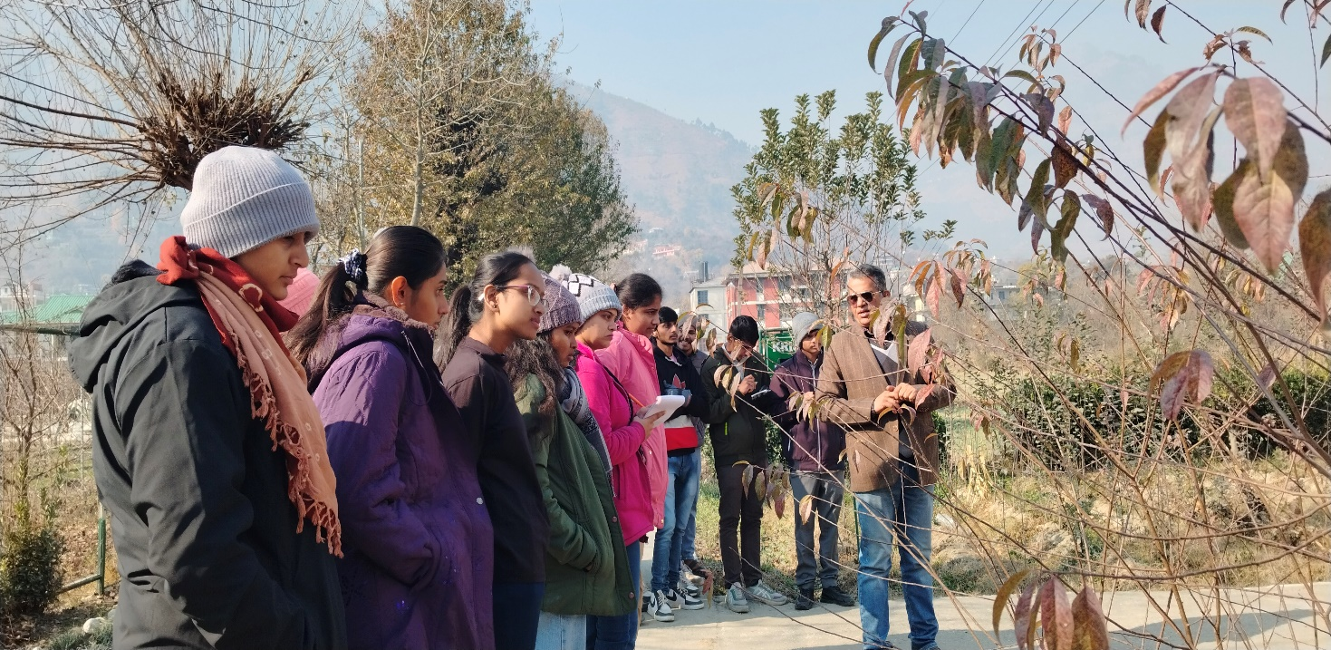

During the visit, students had the opportunity to observe hands-on demonstrations of farming techniques and engage directly with experts. These interactions highlighted the importance of sustainable practices, including soil conservation, water management, and crop diversification. The KVK's role in transferring agricultural knowledge to farmers through extension services was clearly evident, as the center facilitates the adoption of new technologies and practices that enhance agricultural productivity. This exposure helped students gain a deeper understanding of grassroots-level agricultural extension and the challenges faced by farmers in implementing these practices on their farms.

## Visit: Central Potato Research Institute (CPRI), Shimla

### Date : 4/12/2023

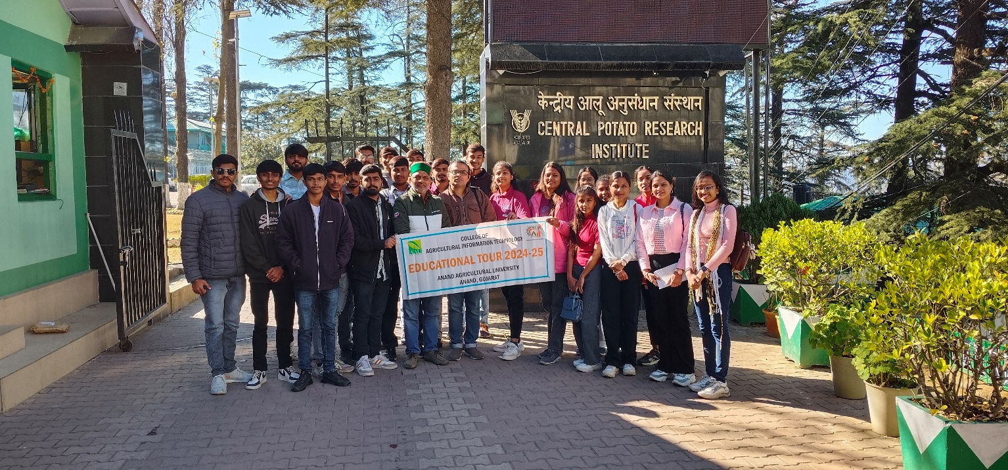

The ICAR-Central Potato Research Institute (CPRI) in Shimla is a leading institute for potato research and development. During our visit, we explored:

* **Research on Disease-Resistant Varieties:** The institute’s efforts in developing high-yielding, disease-resistant potato varieties suitable for diverse agro-climatic zones.
* **Cold Storage Techniques:** Demonstrations on innovative storage methods aimed at reducing post-harvest losses and enhancing the shelf life of potatoes.
* **Processing Unit:** We observed value addition processes such as making potato chips, flakes, and other processed products, contributing to food security and economic benefits.
* **Laboratory Facilities:** The labs are equipped for advanced research in potato breeding, molecular biology, and pest management.
* **Seed Production Program:** The institute’s seed production unit is dedicated to producing quality seeds to ensure high yields and uniform growth across different regions.
* **Climate Change Adaptation Studies:** Research on potato crop resilience against climate variability highlighted the institute’s contributions to sustainable agriculture.

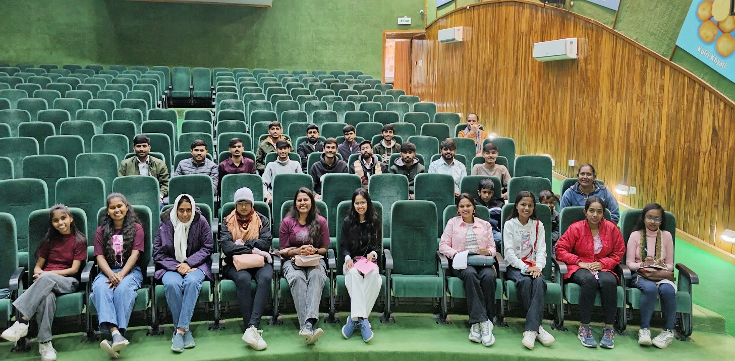

## The Central Potato Research Institute (CPRI) in Shimla is a leading research center dedicated to advancing potato cultivation through innovative breeding and agricultural practices. The institute focuses on developing high-yielding, disease-resistant potato varieties that can withstand diverse climatic conditions. This research is crucial for ensuring a stable and sustainable supply of potatoes, which are a staple food crop in India and globally. In addition to breeding, CPRI emphasizes sustainable cultivation techniques, which include practices for soil health, pest control, and water management, contributing to more resilient farming systems.

## Visit : Indian Institute of Remote Sensing (IIRS), Dehradun

### Date : 6/12/2023

### 

The Indian Institute of Remote Sensing (IIRS) in Dehradun is a prominent institution for education and research in remote sensing and geospatial technologies, operating under the Indian Space Research Organisation (ISRO). IIRS specializes in the application of satellite-based technology for various sectors, with a particular focus on natural resource management, environmental monitoring, and disaster mitigation. The institute’s research and training programs help in understanding the potential of remote sensing to address real-world challenges, including climate change, land use changes, and the management of natural resources like forests, water bodies, and agricultural land.

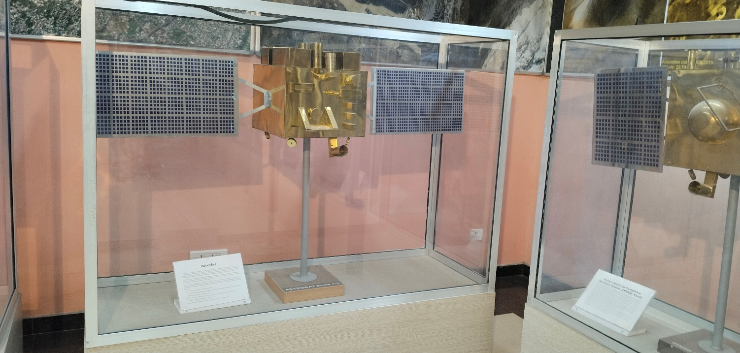

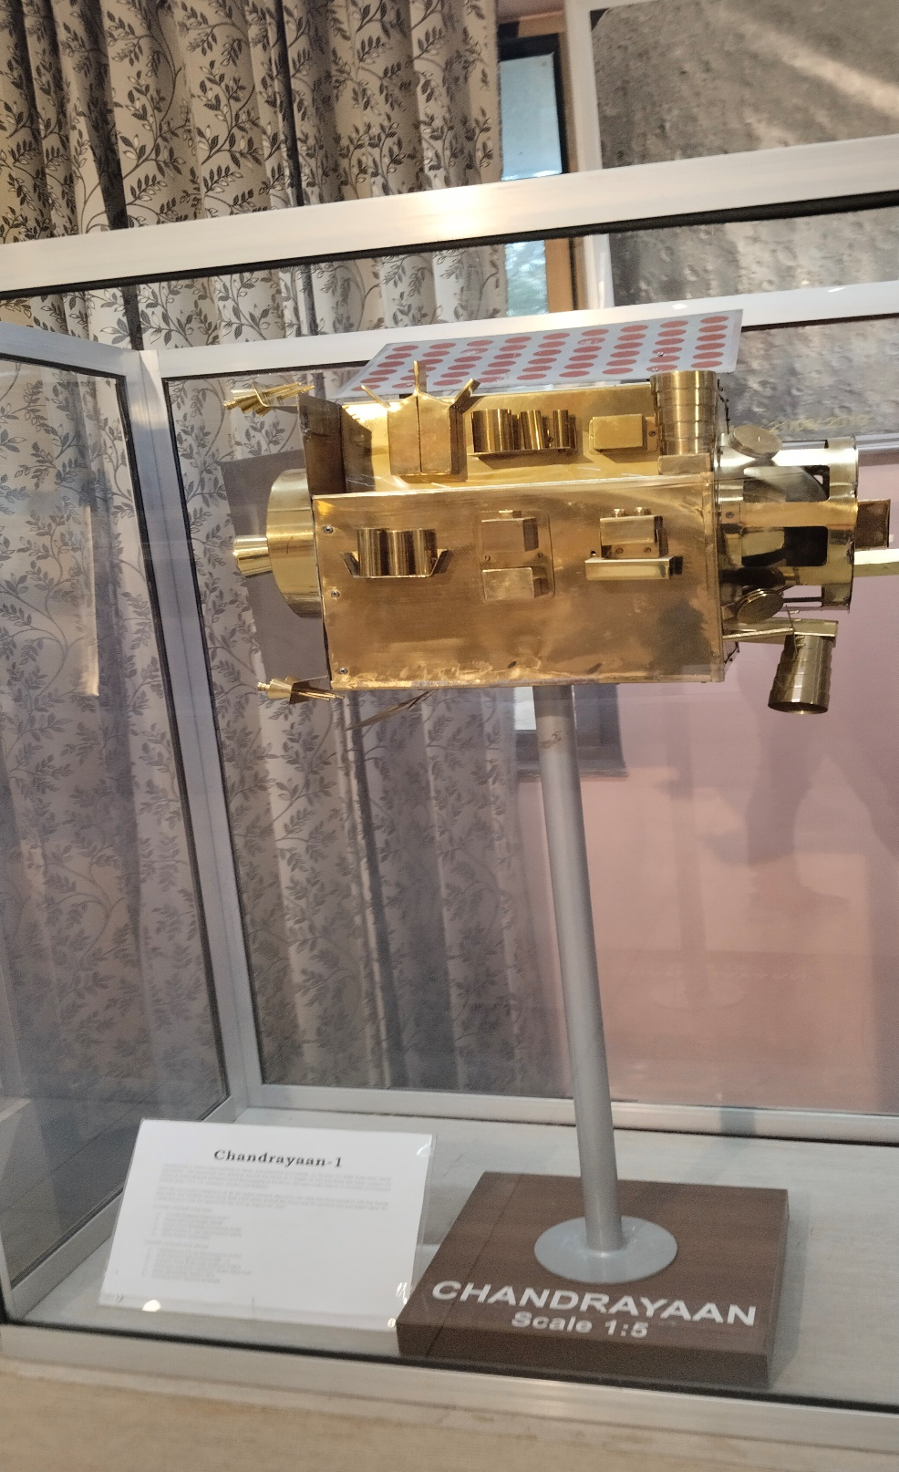

During the visit, students explored various aspects of satellite data processing, Geographic Information Systems (GIS) applications, and how remote sensing contributes to sectors like agriculture, forestry, and urban planning. The institute's expertise in using satellite imagery to monitor environmental changes and support decision-making was evident. Students learned how these technologies are applied for sustainable development, such as improving agricultural productivity, monitoring forest cover, and planning urban infrastructure. The visit highlighted the significance of remote sensing as a powerful tool that integrates space technology with environmental and resource management, thereby contributing to informed decision-making for sustainable development.

## 

## Conclusion

In summary, our educational expedition covered a diverse range of agricultural, technological, and scientific domains, providing a comprehensive understanding of India's rich and varied landscape. From the cutting-edge facilities at IIT Bombay and IISc Bangalore to hands-on experiences in agricultural practices at various universities, each visit contributed to our knowledge and appreciation of the intricate systems sustaining our environment.

The journey led us through aquaculture labs, energy parks, and food processing centers, highlighting the intersection of innovation and sustainability in contemporary agricultural practices. We witnessed the application of advanced technologies in supercomputing, delved into the depths of oceanography, and explored the intricate world of entomology.

The collaborative efforts of scientists, researchers, and students in these institutions underscored the importance of interdisciplinary approaches in addressing complex challenges facing agriculture and related fields. Moreover, the focus on training programs, hands-on experiences, and community engagement initiatives demonstrated a commitment to knowledge dissemination and practical skill development.

The combination of academic insights and real-world applications during the tour not only expanded our understanding of agricultural and scientific practices but also deepened our appreciation for the dedication and ingenuity driving progress in these fields. As we concluded our journey at the spiritual destination of Shirdi, we reflected on the holistic experience that combined intellectual exploration with cultural enrichment, leaving us with a broader perspective on the interconnectedness of education, technology, and sustainable practices in shaping the future of agriculture and beyond.